# Overview

This app produces customizable visualizations of ACS statistics by CCA. The app can produce maps, bar plots, and tables of most ACS variables[1] by CCA. To do this, it takes one of two types of inputs: pre-loaded and aggregated data from a file, or ACS data downloaded in the app via a census API.

Table 1: Inputs and outputs

|  |  |  |
| --- | --- | --- |
| Inputs | 🡪 | Outputs |
| Pre-loaded and aggregated data found in CCA Statistics.csv | Map |
| Bar plot |
| Raw data downloaded from a census API and aggregated in the app |
| Table |

# User Interface

The user selects the data to be represented on the left-hand pane. The graphic can be customized in the right-hand pane. The graphic is presented in the middle pane.

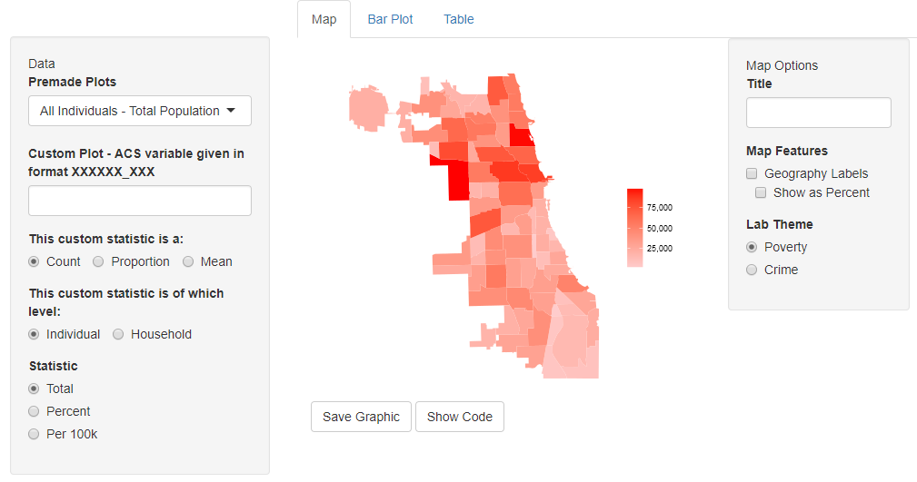

Figure 1: Example of a map

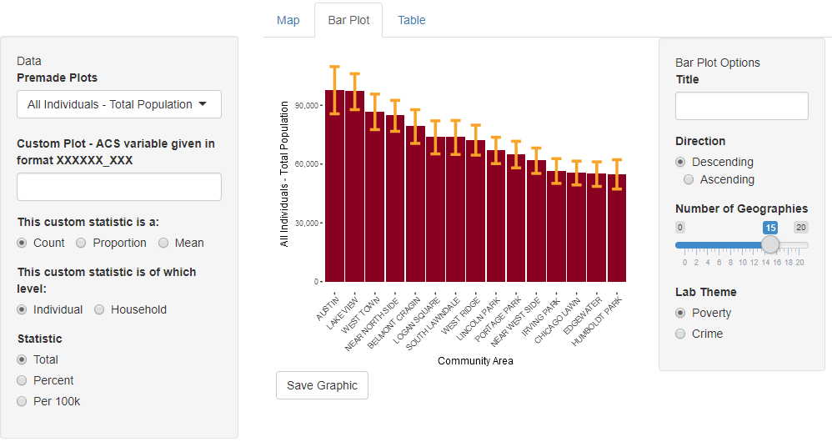

Figure 2: Example of a bar plot

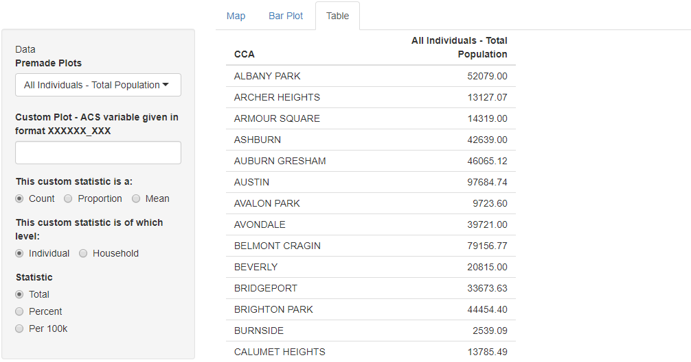

Figure 3: Example of a table

# Current Limitations

1. The census API for downloading ACS data, the R package acs, cannot load variables unless they conform to a specific 9-character format. Not all variables conform to this format, even if they are available at the tract level.
2. Margins of error cannot be aggregated accurately without individual-level data. We will have to use an approximation, but have not come up with one yet.

1. See Limitation 1